# Personal Project Report

## Criterion A

### A(i) - Learning goal

My learning goal was "to learn about animal movement and robotics" which was achieved through the completion of my product goal, "to create an Arduino controlled robot which recognisably mimics a real-life animal”.

My learning goal was linked to my personal interests of animals and robotics, and served to help me further my knowledge in both areas. I would love to explore my passion for animals, by learning more about their biology and anatomy. I have always loved animals. My family have owned 2 dogs (see Figure 1) and a rabbit (Figure 2). My grandparents own several sheep, and have often housed horses, sheep and cows on their farm. We visit often, and I enjoy feeding, patting and spending time with all of these animals. This passion inspired my learning goal, I got to spend more time with all of these animals, studying their biology, and how they move, which was a fun experience, and valuable knowledge to create my robot.

One of my biggest passions at school is computer science. My chosen electives are IST (information software technology) (Figure 3) and Engineering (Figure 4), which I am good at and enjoy very much. In IST, we have looked at programming using the Raspberry Pi, which has many applications in robotics, as a powerful and well-documented computer with many input and output pins for servos, motors, lights, speakers, sensors and cameras. In Engineering, my class has studied mechanisms, forces and simple machines, all of which are integral for the development of a well-made robot. In Year 8, my Design and Technology project was a robot car, made with the Raspberry Pi, as can be seen in Figure 5. My learning goal is to further develop my understanding and aptitude for all these skills, as I learned to use an Arduino, and develop knowledge in using a new programming language, microcontroller and electronic components and in applying physics within a moving robot.

My learning goal combined my personal interests of animals and technology to allow me to develop both passions.

|  |  |  |
| --- | --- | --- |
| Figure 1: My dog. | Figure 2: My rabbit. | |
| Figure 3: My results for one of my recent IST assessments, completed using programming concepts related to what I did for my project. | | Figure 4: The results for my engineering assessment, which involved several simple machines. My high results and the positive feedback show my enjoyment of the subject. |
| Figure 5: I have been developing my understanding of robotics since Year 8, when I made a robot with a Raspberry Pi for my DT project. I further developed this knowledge by completing my learning goal, and learning how to use another micro-controller, the Arduino. |  | |

### A (ii) - Product Goal

The product I made is an Arduino controlled robotic animal. I was inspired to develop this product by observing the movements of animals in my life, and by my passion for robotics.

#### Product success criteria

|  |  |  |  |
| --- | --- | --- | --- |
| Specification Type | Specification for your project | Why? | How will you test it? |
| Aesthetics | The product will resemble a recognisable animal, and will have simple, monochromatic colouring. The robot will be aesthetically pleasing. | Because a monochromatic colour scheme is neat and simple, and works with a variety of other colours (Bacon, 2020). This makes it appropriate for my project, as the other components such as the servos and Arduino have bright colours, and a plain monochromatic colour scheme will mean that these will not clash. | Tested through survey, where participants will rate aesthetics and recognisability. The average score on a scale of 1 to 5 will be given as the final indicator. |
| Cost | I will try to limit the cost of the materials to less than $200. I already have an Arduino, battery pack and monitor, and access to a 3D printer. So I will only have to buy servos/motors, which cost $11.95 each from my local Jaycar. I will also need to buy a display and 3d printing filament, all of which should fit into the $200 budget. | To make my robot I will need at least 8 servos (2 per leg), which should cost at most to $83.60 when bought in bulk from Jaycar, although I could possibly buy them for even less when on sale.  The display should cost at most $40 dollars from Jaycar, as does a coil of 3D printer filament. | Receipts, and using given costs to calculate total expense of project and ensure it is under given maximum. |
| Size | The robot will be at most 30 cm in diameter, as that would be the largest size that could be controlled by servo motors. At its smallest, it will be the diameter of the Arduino with 5 cm added to the radius | This is big enough to fit the Arduino and all components, and small enough to be carried, controlled and managed appropriately. | I will measure the diameter of the robot once fully designed and on completion. |
| Function | The product will be able to stand independently and walk forwards, backwards, left and right on command, and over different surfaces. | According to Merriam-Webster dictionary, a robot is "a machine that resembles a living creature in being capable of moving independently (as by walking or rolling on wheels) and performing complex actions (such as grasping and moving objects)". To have my project meet this definition it will be able to meet this specification. | Repeated testing on different terrain. |
| Material | The product will be made of 3D printed and electrical parts. | This is appropriate as 3D modelled parts can be intricately detailed and measured, and printed exactly as designed, for the lowest margin of error. | Basic observation |
| Sustainability | The product will be powered by a rechargeable battery and/or solar panels. | Sustainable powering options will decrease the environmental footprint of the product, and be more practical for small scale usage, as rechargeable batteries are less expensive than constantly buying new batteries/fuel. | Tested by observation, solar panels will be obvious, while rechargeable battery will be visible when powering. |

### A (iii) - Action plan

The goal of this action plan was to help me scaffold the process of making the product, to improve efficiency and give me direction in the process. The action plan consists mainly of a basic outline of the order of the design and creation process. I also included some dates for when I wish to finish each stage. I have some experience with robotics projects in the past, and I based the timeline around how long these projects took, although this was not entirely accurate, as this project was much more complicated than previous ones.

|  |  |  |  |  |  |
| --- | --- | --- | --- | --- | --- |
| DATE | TASK | TO DO | RELEVANT SUCCESS CRITERIA | PROGRESS (dates completed, adjustments made) | |
| 12/12/2022 | Study animal movement | * Capture footage of different animals moving slowly and at regular pace * Create many basic sketches which show how those animals move, using stick figures and basic shapes to reduce complexity * Take notes on differences between walks of all animals, which limbs are used most and least, which movement is the most simple, complicated, elegant, etc. | aesthetics | 13/12/2022 |
| 12/12/2022 | Choose animal to replicate | * Using the notes and sketches created, decide which to study, based on the ease with which it could be replicated, its appeal as a robot, and general inclination * Conduct more research into the chosen animal | aesthetics | 13/12/2022 |
| 15/12/2022 | Create planning designs | * Create several quick sketches of the animal, in a simple style * Measure the parts needed for the robot (Arduino, servos, battery pack, etc.) * Use measurements and sketches to create multiple basic ideas for the design * Choose one of these designs, and finalise it, getting all measurements, sketches of how it will move, and | aesthetics, size | Initial design finalised 14/12/2022, designing completed 30/06/2023 |
| 16/12/2022 | Research Arduino and physical computing | * Research and practice using the Arduino to control servos, sensors and display * Create basic functions to move each servo in the required directions | function | Completed 17/12/2022, some further research conducted until 29/06/2023 |
| 17/12/2022 | Mock-up final product | * Use cardboard, tape and other household materials to connect electric components. * Attach servos and program all parts so that the robot has basic movement * Experiment with design to allow model to walk roughly as desired | function | First mock-up completed 30/12/2022 |
| 21/12/2022 | Model robot | * In Solidworks, create a 3D model of all of the robot's parts, assembling them digitally to simulate the final product. | materials | Multiple versions created. First part finished 17/01/2023  Final digital version created 26/06/2023 |
| 01/01/2023 | Print and assemble parts | * 3D print all parts, remove scaffolding and assemble. Use hot glue if needed, but ideally parts should click in and out of structure easily. Insert all electronic components | cost, material, function | First parts printed 03/03/2023.  Final print 05/07/2023 |
| 05/01/2023 | Program | * Use c# and the code from previous steps to program basic functions for different movements in Arduino IDE | function | Code finalised |

## Criterion B

|  |
| --- |
| Elder Dog walk cycle | kylejordaan |
| <https://www.thenakedscientists.com/articles/science-news/how-do-dogs-walk> |

### B(i) - Learning Goal

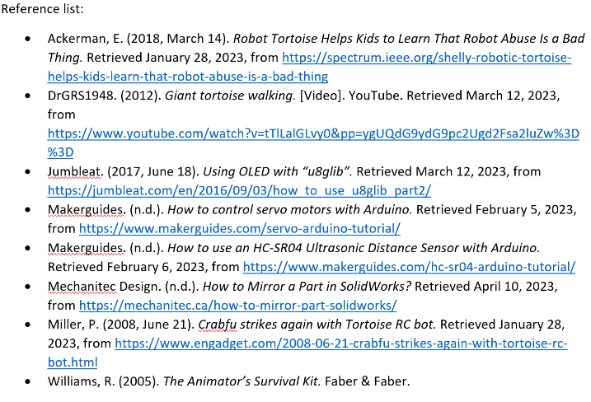To achieve my learning goal and learn about animal movement and robotics, I needed to use the ATL skill of **researching widely and efficiently**. Using the ATL category of **research**, I was able to find information in a variety of formats, including images, videos and articles, and to interpret this information to make connections and build understanding. For example, when researching quadrupedal walks, specifically dogs, I referenced an animation manual which showed how dogs walking are animated, and compared that with an article discussing the limb preferences of all quadrupeds, to document the correct walk cycle and better understand this aspect of animal movement. This research can be seen in Figure 6. Another application of ATL research skills in achieving my learning goal was the **evaluation and selection of sources and digital tools based on their appropriateness for specific tasks**. While learning how to use specific components with the Arduino, I had to trawl through masses of tutorials to find those which were specifically applicable to my project and used the same models as I was (Figure 7). This allowed me to properly apply the advice given, and build my understanding in this area of robotics. Through the application of ATL research skills such as evaluating, interpreting and sourcing information, I have been able to achieve my learning goal and better understand animal movement and robotics.

Figure 6 – clippings from the Animator’s survival kit and a website used in researching quadrupedal walks.

Figure 7 – my reference list for the project, including specific tutorials for component of the robot.

Another ATL Category which I used in the achievement of my learning goal was **critical and creative thinking**. To learn about animal movement, I needed to explore many different animals, and their movement styles and biology. By considering many options, even those which would struggle to fit my brief, and by imagining the possibilities for those options, I was able to gain understanding around many different organisms, and to **discover new solutions** to achieve my product goal, while developing my learning goal. By drawing, gluing and pasting animal walks, and comparing them by listing positives and negatives, I was able to **view challenges and benefits** of mimicking these animals in my robot, and had the opportunity to **consider other solutions** to my problem, while learning about a variety of animals. In using creative and critical thinking skills, and considering every possibility, I was able to brainstorm and discover a variety of solutions, and to research many animals and their movement styles. This research can be seen below in Figure 8.

|  |  |  |  |
| --- | --- | --- | --- |
| **Figure 8 – how I used Thinking Skills in the accomplishment of my learning goal** | | | |
| **SKILL** | **EXAMPLE/EVIDENCE** | **EXPLANATION** | **DEVELOPMENT OF LEARNING GOAL** |
| Thinking Skills -   * Consider all alternatives * Use multiple processes and diverse perspectives to explore alternative solutions * Consider the seemingly impossible * Create original works and ideas and visualize alternatives * Practice flexible thinking- arguments both sides of an idea or issue * Seeing possibilities, problems and challenges positively * Change the context of your project to gain different perspectives | CISVaq  (1€)0  CISVaq  (1€)0 | I had originally decided to create a robot spider, but instead I decided to branch out and consider other animals to use for my project. I researched the walking patterns and compared the features of different animals to decide which to use in my project. Once I had done my research, I evaluated each option, listing positive and negative qualities to make a final decision about which animal to use. | This helped me to develop my learning goal of learning about animal movement, as I was able to research many different animals and consider their features. |

### B(ii) - Product Goal

To create my robotic tortoise, I needed to use a variety of approaches to learning. ATL skills under the categories **Research, Self-Management, Thinking and Communication** were all necessary to plan and create my product within the set deadline and to the standard outlined in the success criteria.

The first stage of the product creation was centred around Research. To develop an understanding of the technical components and software required, I used **Information and Media Literacy Research skills to access a variety of sources and analyse them**. For example, to create 3D models of parts, I needed to research examples of real life and robotic tortoises to serve as inspiration for my design (Figure 9). Then, I applied Media Literacy ATLs to use and interpret a range of content-specific terminology related to Solidworks, in order to understand how to create and combine CAD modelled parts.

The next section of the creation of my robot required both Self-Management and Thinking skills. I used Organisational Self-Management ATLs, by recording my creative process and research in a notebook in order to have an **organized and logical system of information and files** (Figure 10). This notebook allowed me to have a more efficient creative process, and to refer back to my past ideas while creating the robot and this report.

**Critical and Creative Thinking Skills** were necessary **to break down the project into smaller parts, generate ideas and manage workload**. I started with a general sketches of the tortoise’s shape, then identified the logical separation of the body, into head, base and multiple leg parts for ideal mobility and structure. Once I had decided upon this division, I created numerous sketches and 3d models for each part, slowly perfecting the design. For example, Figure 11 shows my original ideas for the shape of the tortoise’s leg, figure 12 the improved design, while figure 13 shows the final shape of the upper leg. Using Critical Thinking Skills, I was able to evaluate my early sketches and identify areas for improvement in the design, and make the best possible product.

|  |  |  |  |
| --- | --- | --- | --- |
| SKILL | EXAMPLE/EVIDENCE | EXPLANATION | DEVELOPMENT OF PRODUCT GOAL |
| Research Skills  Information Literacy    Collect and analyse data to identify solutions and/or make informed decisions | Screenshot of brainstorming  Figure 9 – evidence of research to find inspiration for the tortoise design | These images were collected from a variety of sources, to serve as references and inspiration from which to create designs for my robot tortoise. I used my research skills to find authentic photos and similar projects to allow me to make informed decisions about the best design options to make a recognisable tortoise which met the success criteria. | This helped me to develop my product by providing inspiration and reference for the creation of designs for the robot tortoise. |

|  |  |  |
| --- | --- | --- |
| Figure 10 - Some pages from my notebook (out of order), including sketches, research and reminders about the structure of the personal project |  |  |
|  |  |  |
|  |  |  |

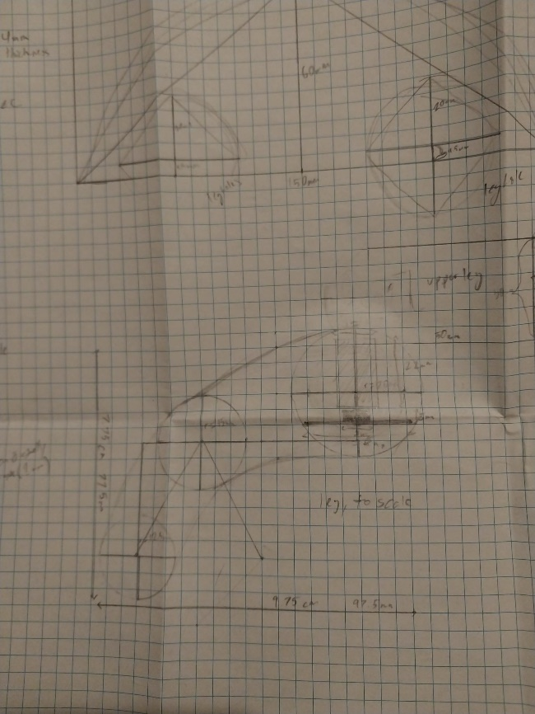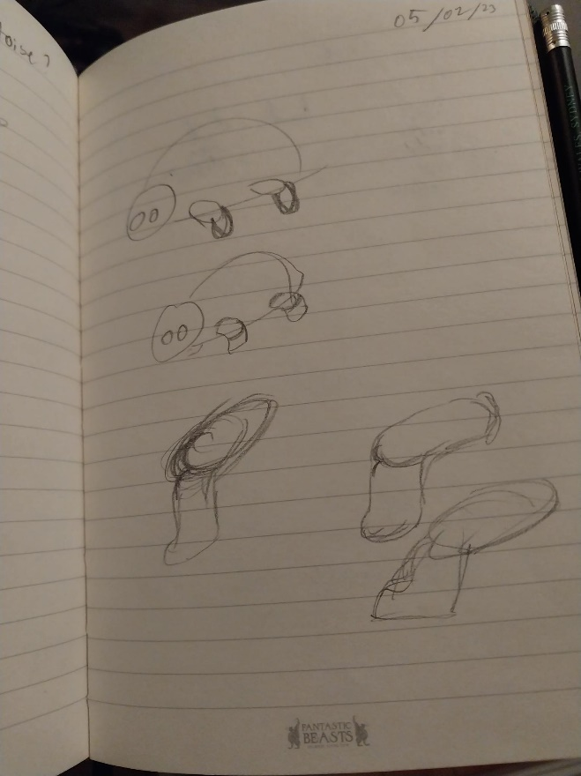

Figure 12, improved leg design

Figure 11, initial ideas for leg design

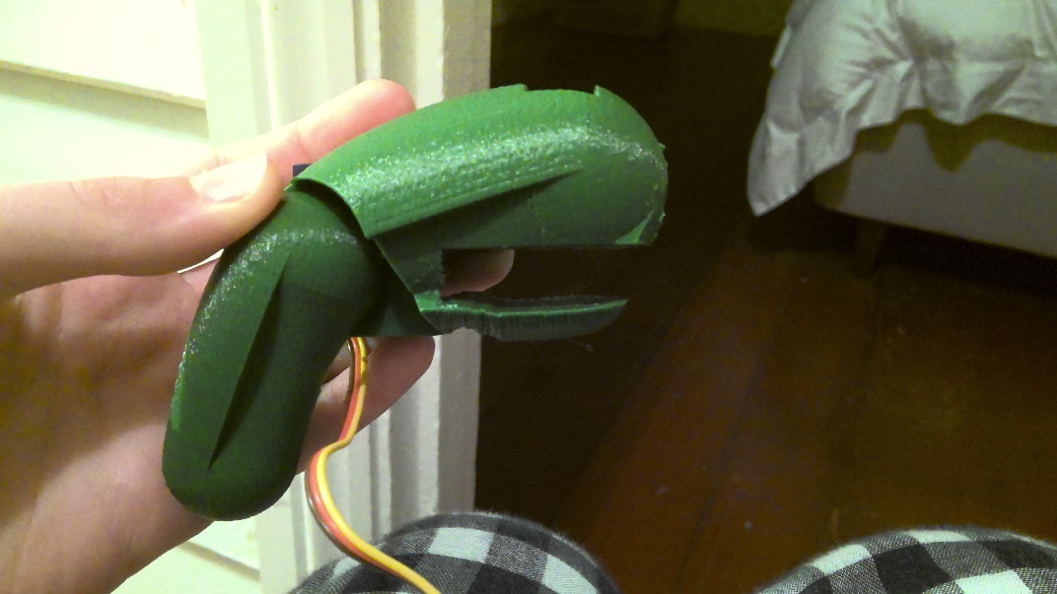

Figure 13 – final leg shape after significant modification

## Criterion C

Figure 14, the final product

### Criterion C (i) – Impact on yourself as an IB Learner

My product goal was to create a robotic animal, using technologies and techniques with which I was unfamiliar. The final product, which can be seen in Figure 14, was the product of hours of research, sketching, CAD modelling, 3D printed revisions and programming.

My learning goal, which helped me in the creation of my product, was to learn about the Arduino, the microcontroller powering the robot, and animal movement, to mimic in the robot's design.

I initially believed that the research I completed for my learning goal, and that which I already possessed, would be sufficient to create my product. This was not the case. Constant research into specific areas of electronics and CAD modelling was necessary to realise my ideas. For example, the unsymmetrical leg parts needed to be mirrored, so that the servos faced inwards, and the legs could rotate the full distance required. Although I was able to create the original part, I found that I lacked the knowledge to mirror the parts. Following the principles of the IB 'Inquirer' learner profile, I researched widely to gain required - and extra - knowledge.

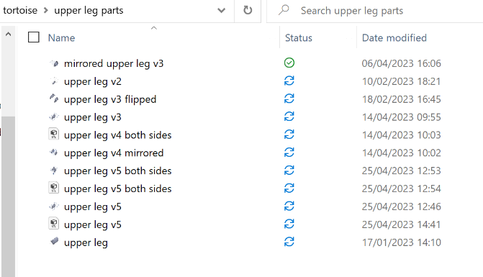Another delusion I had was around the number of prototypes required to get to each finished part. Although some parts, such as the head, required only one revision, the design for the upper leg involved 7 Solidworks revisions (Figure 15), 17 printed parts (Figure 18), and countless hours of sanding, gluing and filing, before it reached an acceptable standard. This process was hugely influential in improving my ability focus, and from it I learned how to record required changes, to ensure that the newer revisions did not have the same problems as the previous. This skill will be hugely beneficial in future projects, as no design is ever perfect on the first revision and understanding this and knowing how to undergo the process will allow me to create better parts in the future.

Figure 15, all the digital files involved in creating the upper-leg part

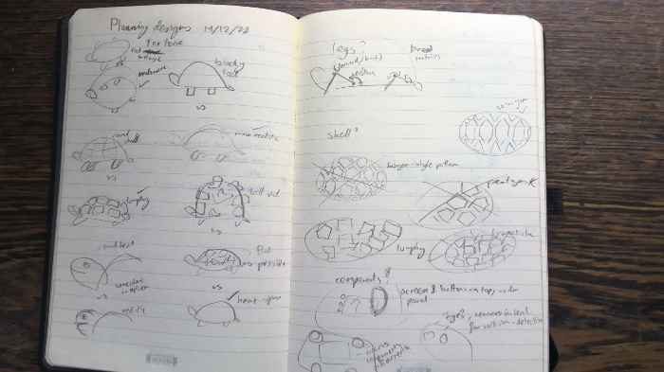While creating planning designs, I identified that the drawing element of the process was a personal weakness. However, this revelation inspired me to create more sketches, spend more time on each one, and ultimately allowed me to raise my drawing skills to an acceptable level. On the left page of Figure 16 is some earlier sketches, while the right page was sketched with greater care.

Figure 16, sketches of varying quality

This project helped me to understand myself and the sort of learner that I am. I used a variety of skills, associated with the IB learner profiles of Reflector, Inquirer and Thinker. Figure 17 is a table which shows how I incorporated the values of these learner profiles into my project. Specifically, I connected with the **Thinker** profile, which I believe best describes my learning style. For example, while creating the product I used creative and critical thinking skills to imagine and realise solutions to problems such as the robot’s inability to stand up under the full load of the body.

|  |  |
| --- | --- |
| **IB Learner Profile** | **How I used this profile in the PP process** |
| **Reflector** | I needed to be reflective to complete my product, as I had to compare and critique designs and parts of the robot. Annotating designs and constantly documenting process allowed me to identify strengths and weaknesses of each sketch based on the success criteria created. |
| **Inquirer** | To gain the knowledge necessary to achieve my product and learning goals, I needed to explore widely into the world of computing. For example, I researched widely to develop knowledge of the Arduino, completing mini projects to test the function of each component, including sensors, servos, and the display. |
| **Thinker**  Figure 17, how I used IB learner profiles in my project | Transforming the abstract idea of 'robot' into a functioning model involved critical and creative thinking, as I identified key requirements and features of the robot. For example, making the robot legs strong enough to hold up the body required planning and revision. Problems and possible solutions were recorded in a notebook, and some problems, such as having free-moving legs able to hold up the body, necessitated complex creative thinking skills to solve. |

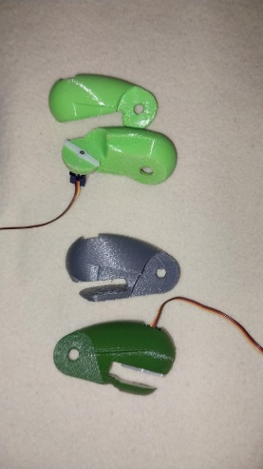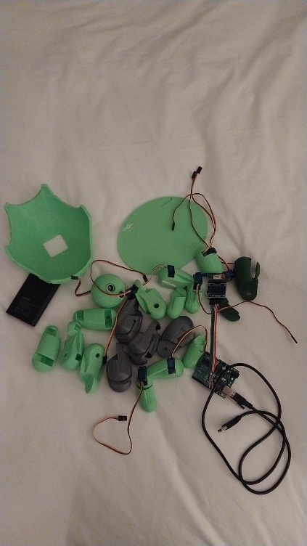

Figure 18, the 3D printed parts involved in perfecting the upper leg design

### Criterion C (ii) – Product Evaluation [400 words]

To evaluate the success of my product I conducted a survey (see Figure 22) using Microsoft Forms. I asked my friends to complete it because they could give me honest feedback at short notice. The results of the survey (see Figure 21) showed that there were both strengths and weaknesses with my product. I used this information to help me evaluate my product outcome. I used an evaluation table to investigate each of my original success criteria, which can be seen below in Figure 19. My evaluation showed that aesthetics and affordability were strengths of my product because the robot was recognisable and aesthetically pleasing, and the cost of the project was more than $60 under budget (Figure 20). My evaluation also showed that function and sustainability were weaknesses because the robot was not able to support itself and was made of plastic parts. If I made this product again in the future I would change the design of the legs to improve their strength and change the way in which they were powered to better position the servos. However, if I made this product again I would keep the designs of the shell and head because they were recognisable, cute, and interesting. Overall, as I met 4 out of the 5 success criteria, this product was successful in meeting my product goal.

|  |  |  |
| --- | --- | --- |
| Figure 19, an evaluation table for success criteria | | |
| Success Criteria | Success? | Comments |
| Aesthetics *- The product will resemble a recognisable animal, and will have simple, monochromatic colouring. It will be aesthetically pleasing* | Yes, 85% said that it resembles a tortoise, and it was rated 4.17 out of 5 for aesthetic appeal. | Tested through survey (Figure 22), results in Figure 21 |
| Cost *– the project’s budget will be less than $200* | Apart from the 3D printing costs, which I was fortunately not required to pay as the school provided free services, and parts I already owned from previous projects, the total expense was $136.45, significantly under budget. | If you didn’t already own an [Arduino Uno](https://store-usa.arduino.cc/collections/boards/products/arduino-uno-rev3) and [battery pack](https://www.miniso-au.com/en-au/product/240555/5000mah-power-bank-with-2-usb-ports-model-mc-029-black), then this would cost an added $57.59, raising the cost of the project to $194.04. Including tools such as the soldering iron and wires, the project would go over budget, but I was lucky enough to already have this equipment. |
| Size *– up to 30 cm in diameter* | Yes | The shell, the largest part, is 19.6 cm by 15.9 cm. |
| Function ­*- The robot will be able to stand independently and walk forwards, backwards, left and right on command, and over different surfaces* | No, the legs are not strong enough to hold the body. |  |
| Material *- The robot will be made of 3D printed and electrical parts* | Yes, the parts are 3D printed, with digital servos and sensors powering it. |  |
| Sustainability *- The product will be powered by a rechargeable battery and/or solar panels* | Controlled by Arduino which is powered by rechargeable battery.  Unfortunately, 3D printed parts are made of plastic, and there are many of these parts. |  |

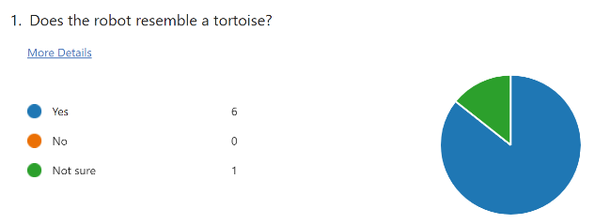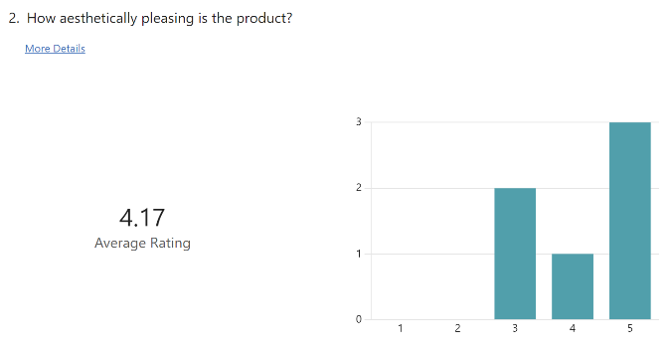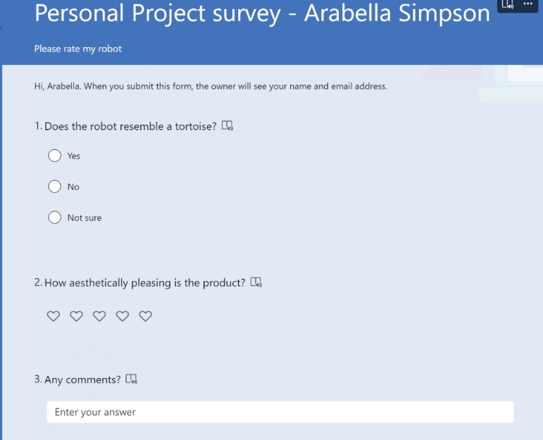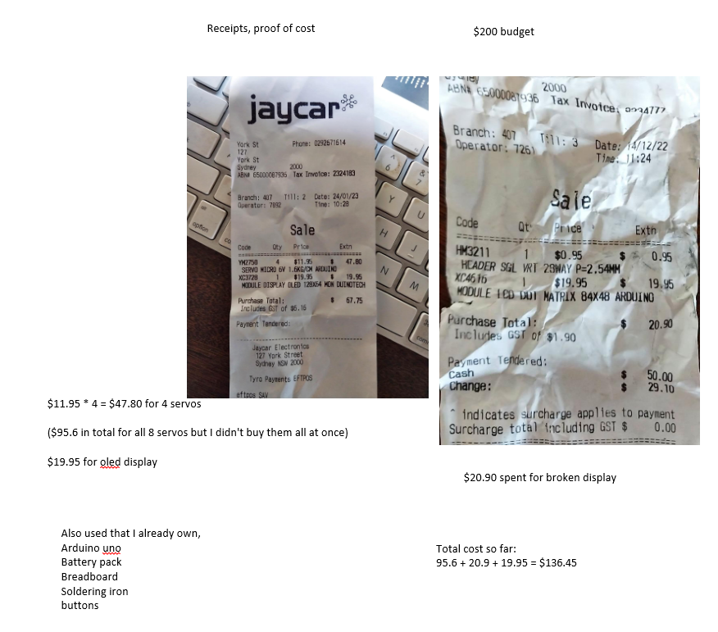

Figure 20, a digital record of expenses, including receipts and calculations

Figure 21 the results of the survey indicating the success of the aesthetics criterion.

Figure 22 - Survey to measure success of aesthetics criterion